The Feast of the Ascension of the Lord 2026
Forty days after the resurrection, Our Lord Jesus Christ, in the presence of his disciples, was “lifted up…..and a cloud took him from their sight”. This event we call “The Ascension of the Lord”. From earliest times artists have sought to depict the Ascension, often showing Jesus rising into the sky, surrounded by swirling cumulus clouds. Perhaps one of the most extraordinary paintings of the Ascension is that by the medieval German artist, Hans von Kulmbach. He depicts the apostles and the Virgin Mary, standing looking up into the sky, while all that is visible at the top of the painting are the feet and lower legs of Jesus, protruding from the enveloping clouds!

Artists have struggled to convey to the wonder of the Ascension, but they failed in their endeavours as it is not possible to record an image of what actually took place on that “fortieth day” after the resurrection. The image of Jesus flying up to heaven, with heaven located somewhere beyond the stars, is not only limited but also misleading! This feast of the Ascension challenges us to push out of our minds such images, and to begin to think with the mind of the evangelist, and to understand the language of the Bible.

The evangelist takes us back to the beginning of creation, and where, symbolised by the Garden of Paradise, heaven and earth were in perfect harmony - there Adam and Eve lived, and there, God walked “in the cool of the day” (Gen.3:6). But this harmony was catastrophically disrupted by humanity's sin - the tragic consequences of the disobedience of Adam and Eve. But God's loving plan was to reunite heaven and earth, to heal the fracture and to bring about a whole new world, united and transformed. This was the astonishing and world-shattering renewal that began with the crucifixion and resurrection of Jesus; this is the spark that set off the revolution of Christian love, here is the source of the love-energy that God desires to pour through us in order to transform the world. This is the purpose and mission at the heart of Christianity.
The Feast of the Ascension helps us to understand this extraordinary interlocking relationship between heaven and earth. The Scripture tells us that, “(Jesus) was lifted up while they looked on, and a cloud took him from their sight.” But we must interpret these words with the mind of the evangelist. “Lifted up” doesn't mean that Jesus ascended to somewhere “up there beyond the clouds”; rather, he entered into another dimension, into God's dimension, that which we call heaven. The “cloud” that took him from their sight was the symbol of that heavenly reality into which Jesus entered. Although beyond sight of human eye and touch of hand, Jesus, nevertheless, remains ever present - "he ascended from his disciples without departing from them" (Pope St Leo the Great).

Today’s feast also helps us to understand more clearly what happens, after death, to the souls of the faithful. Just as Jesus ascended to the heavenly dimension, which he himself called, “my Father’s house”, so do the souls of the blessed. Heaven is not a physical destination, a celestial storeroom for eternal inactivity! “Going to heaven”, as we commonly say, is going to a person, being with God, in loving companionship, and in the joy of heaven’s company. Being present in God’s dimension of reality is far from inactivity, but a constant loving intercession for those still in the earthly dimension. This is the basis of our devotion to the Blessed Virgin Mary and the saints; but not only that, it allows us to know that when we sense the presence of a deceased loved one, this is an authentic experience. They too, like Jesus, are beyond the sight of eye, and touch of hand, in another dimension, yet nearby, with us, close to us, and continuing to love and to care for us.

The implication of today’s feast is contained in the challenge to the disciples, “Why are you men from Galilee standing here looking into the sky?”. The Risen Lord had given instructions, “Go, therefore, make disciples of all the nations”. Even after his Ascension, Jesus continued to work and to teach, and he did it is through his disciples. And he continues to do it through you and me, if only we let ourselves be energized by his Spirit, as did the Apostles in their day. And the attributes of Spirit, which St Paul lists as, “love, joy peace, patience, kindness, generosity, faithfulness, gentleness, and self-control” (Gal.5:22-23). Love is willing good for another; joy disseminates itself; patience bears with the troublesome; kindness makes others gentle; generosity benefits our neighbour; faithfulness is dedication to a spouse or friend; self-control restricts the havoc that self-centredness can cause (cf Robert Barron, The Strangest Way, p.167).

In our very ordinary, frequently muddled, often frail, lives, where do we find the love-energy to engage with Christ's commandment, “Go and announce the Gospel of the Lord”? It is when we are united with the Lord Jesus in Holy Communion – that is when heavenly-love spills into our lives, and through us into the world.

“Lord Jesus,
we hear you say, “Know that I am with you always”.
May we always be convinced of that truth.” Amen.

The Ascension of Christ
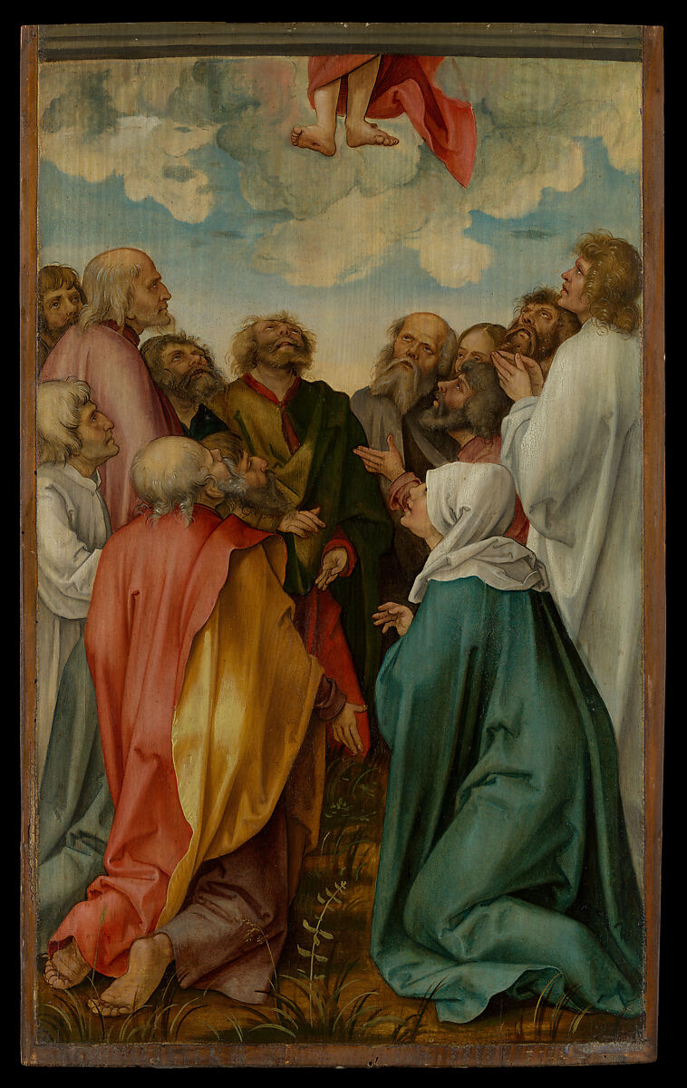
Hans Süss von Kulmbach German
1513

Image Source: https://www.metmuseum.org/art/collection/search/436835

